INDEX of AI_LONG_D Excel File – sheet order with descriptions
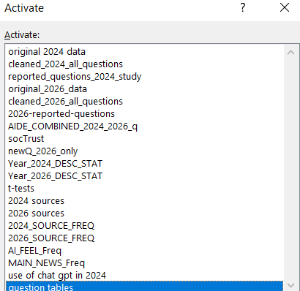
The dataset is from survey responses in 2024 and 2036. The original data is what was exported from Qualtrics. The cleaned version just removed all the qualrics internet capture variables (ie ip address, coordinates, etc). The cleaned version did not remove any missing values BUT it did remove erroneous or test entries. The reported questions for 2024 and for 2026 are those selected variables reported in the paper.
The AIDE combined just like is reads it’s the 2024 and 2026 combined to be used for analysis.
The soctrust file is two other questions that were asked in 2024 and 2026 and never reported in the first paper. They should be added to the AIDE_COMBINED_2024-2026q sheet. The only reason I did not do this was because it was an afterthought and my R script code doesn’t have those variable names in it and wouldn’t run.
The new Q 2026 are the questions asked only in 2026 and they can be found on the question tables tab.
The rest of the sheets are exactly what they say they are the results of the r code statistics used for analysis and charting. (yes I did it old school excel way due to crunch time).
The use of chatpt 2024 sheet was just a way I used to try to determine how many people used chatgpt in 2024. That question wasn’t asked that of respondents directly (we did in 2026) so this was an attempt of estimation.
Lastly, the question sheet is just what is says, is the tables of the exact word statement of each question we asked from the variables we were analyzing. As you already know there is a lot of other things we haven’t talked about yet…and that is why God made sequel and sequel and sequsls….

